A Drop in the Bucket
Overview
Students will learn about water usage and how water is a renewable resource, but it is limited.
Background
Note: if you would like, you can start the discussion off with the earth ball toss.
Have the students toss the ball so that everyone catches it. When they catch it, have them remember what their right thumb lands on: water or land. Then separate them by land and water. Typically, there will be significantly more that land on water than land. This can lead into the following discussion.
- What percentage of the earth is water?
  - 71%
- What is potable water?
  - It is water that is safe to drink or to use for food preparation
- What are some uses for potable water?
  - Drinking, cooking, cleaning, laundry, showering, brushing teeth, garden/agriculture, manufacturing, power, recreation, wildlife, etc.
- Is water a renewable or nonrenewable resource?
  - It is a renewable resource, but it is limited.
  - It is replenished through the water cycle.
- What are some ways that we can conserve water?
  - Turn off the water when you are not using it
  - Limit shower time
  - Refrigerate water instead of running it until it is cold
  - Water lawns in the morning or evening when evaporation is less
  - Collect rain for watering
Supplies
- 1000 ml cylinder
- 100 ml cylinder
- 50 ml cylinder (2)
- 10 ml cylinder
- Eye dropper
- Bucket
Directions
- Fill the largest cylinder with 1000 ml of water
- Explain that this is the total amount of water on the earth.
- Pour 30 ml of this water into the second largest cylinder.
- Explain that this is the amount of fresh water on earth (about 3%)
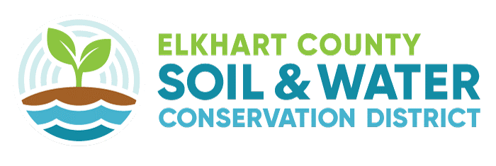
- Of the 30 ml of water pour 6 ml of it into the smallest cylinder
- Explain that this is the amount of unavailable freshwater and what was left in the larger cylinder is fresh water in the glaciers and ice caps.
- Take the dropper and put one drop in the metal bucket. If students are quiet, they will hear it hit the bucket.
- Explain that this is the amount of water that is not polluted and is available for use.
If you would like, you can have the students log their water usage using the Student Worksheet. Have the student log their water usage by filling out the chart. The mark down the activity (example: taking a shower), time spent doing that activity (example: 20 minutes), how much water was used during that time. To calculate how much water they used, the students should research how much water each activity uses.
Students Worksheet

It is important to realize how much water we use as it is a precious resource we should protect. Below is a chart that you can use to log your water usage in a day. Fill out the activity and the time spent on that activity. Then calculate the amount of water you used by doing research on how much water each activity uses. Then answer the questions below.

Activity | Time | Amount of water used
Showering | 20 minutes | 2.1 gallons/minute X 20 minutes = 42 gallons of water

What is your daily water usage?
Which activities use the most water?
Did the results surprise you? Why or why not?
Are there ways you can reduce your water usage?

